ER Diagram – Posts Database

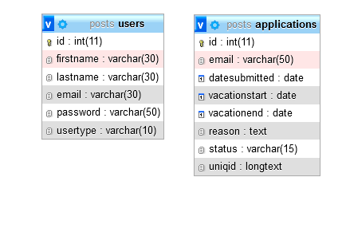

Our database is called posts. In posts there are 2 tables , one called users and the other one called applications.

On the users table, we have the primary key auto-incrementing called id, the first and last name of the user , his/her email , the password and the usertype(by default it’s user, the other option is admin.)

On the applications table, we have the primary key auto-incrementing called id as well, the email of the user, the date that the request is submitted, a date field on the start and on the end of his planned days, the reason as text, the status which is by default pending (an email is sent to the supervisor upon submitting it, where he can change it to accepted or rejected.) Lastly, we have a uniqid of type longtext, which is a hash-id of the application that we can manage through our code.

**Database Queries:**

CREATE DATABASE posts;

----------------------------------------------

CREATE TABLE users (

id int(11) NOT NULL AUTO_INCREMENT,

firstname varchar(30) NOT NULL,

lastname varchar(30) NOT NULL,

email varchar(30) NOT NULL,

password varchar(50) NOT NULL,

usertype varchar(10) NOT NULL DEFAULT 'user',

PRIMARY KEY (id)

);

----------------------------------------------

INSERT INTO 'users'

('id', 'firstname', 'lastname', 'email', 'password', 'usertype')

VALUES

(NULL, 'George', 'Zalokostas', 'gzalos6@gmail.com', 'admin', 'admin');

----------------------------------------------

CREATE TABLE applications (

id int(11) NOT NULL AUTO_INCREMENT,

email varchar(50) NOT NULL,

datesubmitted date NOT NULL,

vacationstart date NOT NULL,

vacationend date NOT NULL,

reason text NOT NULL,

status varchar(15) NOT NULL DEFAULT 'pending',

uniqid longtext NOT NULL,

PRIMARY KEY (id)

);